New Event Coming to DC-G IN 2020!!!
Goal: 70 cakes
What: Athletic Booster Cake Auction
Where: Meadows Commons and Gym
When: Friday, February 14th, 2020 - Norwalk @ DCG Basketball Game
Time: Live Auction Times – Girls Halftime (6:40pm) Silent Auction – 5pm-8:30pm
In-between games (7:15pm) Cake and Ice Cream Social 5pm
Boys Halftime (8:15pm)
How does a business participate????
- Enter a cake that promotes your business (add gift cards to the cake to bring people in to your business.)
- Attend and be a bidder!! You bid on and win a cake at one of the live auctions your name and business name will be announced in front of 2,000 people!!! Good natured rivalries between businesses can be developed during this process.
- Donate $100 to have your business logo on a sheet cake for the cake and ice cream social. We only need 3 or 4 of these sheet cakes so you must contact DC-G Activities Director Brent Buttjer at brent.buttjer@dcgschools.com for this opportunity!!
- I will have some complimentary game tickets available soon that we will get out to the business that show some interest in this event. Again, email Brent Buttjer and he will get those tickets to you for admission

Cake Auction theme: I DC-G!!! (Add your group to the end!)
Cake Registration begins at 4pm on February 14th in Meadows.
3 Divisions for judging determined by WHO made the cake: Professional, Amateur, Student/Staff/Team. 1ST, 2ND, 3RD, AND HONORABLE MENTION RIBBONS!!

This cake was made by a professional for a high school softball team. It sold for $1,000!!
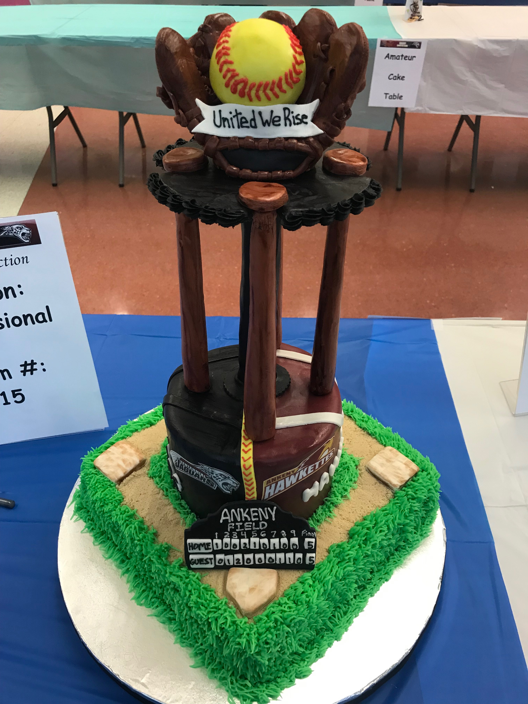

BIDDERS DRIVE THIS AUCTION…..BUSINESS LEADERS COME BID ON A CAKE!!
DIRECT QUESTIONS TO BRENT BUTTJER, DC-G ACTIVITIES DIRECTOR

